Design Rationale

Figma

Colour Scheme

Light theme

51606F (nav bar)

B3DAFF (background color)

Dark Theme:

91B1CF (nav bar)

204669 (background color)

We chose a blue overall colour scheme because we thought that it would represent the games overall blue background. We decided to go for a light and dark colour scheme. For the light colour scheme generally we wanted a light blue background while the dark blue navigation bar would help it stand out from the background colour scheme. As for the layout we chose to insert images and have a hamburger menu for convenience of people. We chose the ori font for headers as we thought that it would help immerse our players in our website better. As for the text we used Min Sans for font that’s easy on the eyes that’s closer to standard font for text.

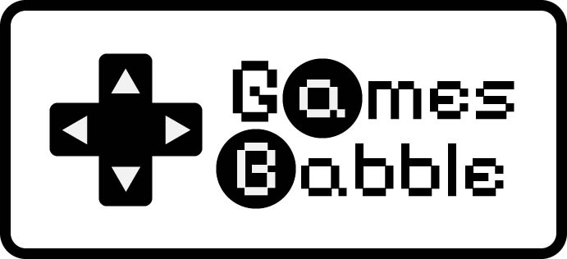

For our logo we chose to follow a game controller design more specifically the N64 game controller. We chose this as the word games would usually be represented by a device that is related to games hence we chose a game controller. With a colourful background on our app we chose to use a monochromatic background hence we chose to use black and white only. Our choice of font is Pixelify Sans this is because we wanted our logo to have similar designs to dialogues in old games such as ones that are played with a N64 controller. We then used the directional pad to further enforce the idea of the controller while the a and B of the games babel